Exercises: Data Types, Expressions, Statements
Problems for exercises and homework for the “JavaScript Fundamentals” course @ SoftUni. Submit your solutions in the SoftUni Judge system at https://judge.softuni.bg/Contests/308.
- Hello, JavaScript!
Write a JS function that can receive a name as input and print a greeting to the console.
The input comes as a single string that is the name of the person.
The output should be printed to the console.
Examples
Input | Output
Pesho | Hello, Pesho, I am JavaScript!
Bill Gates | Hello, Bill Gates, I am JavaScript!
Hints
We would get the name from a single string variable that would be passed to our method.
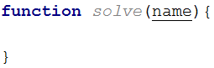
We need to concatenate three strings – the two static parts of our greeting and the name of the person in the middle. We can do this by simply adding the three strings with the addition operator. Since this is an operation which returns the concatenated string, we can directly perform this expression in a call to console.log(). Note the space at the end of the first string:
You should be ready to submit your solution to the judge system. Open the judge contest for this homework and submit your code: https://judge.softuni.bg/Contests/308. It should look like this:
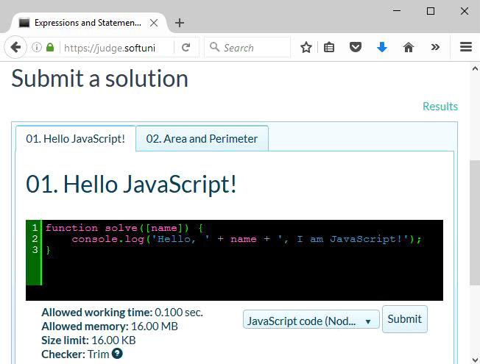
The judge system should accept your solution as correct:
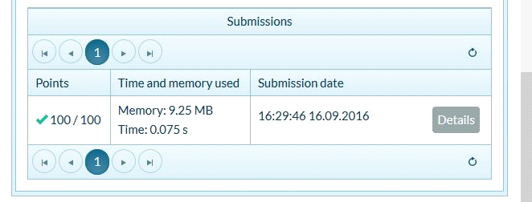
If you get an error, you can see what went wrong in the detailed report, using the highlighted button:
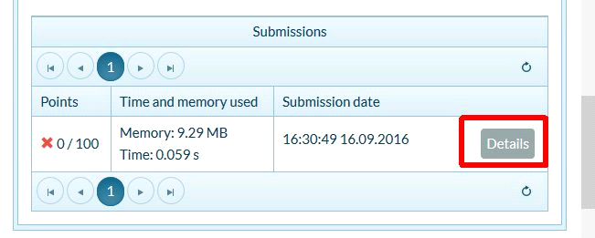
Here you can see what the system expected and what your program’s result was. You can also see what the input for the test was:
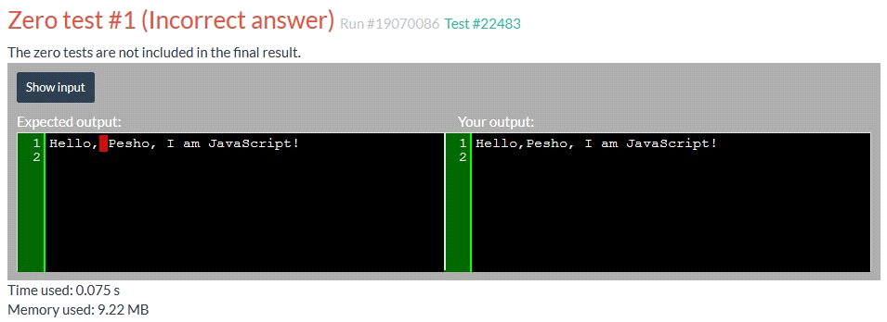
Note you can only view detailed information for zero tests – they do not give you points, but are handy for finding typos and debugging some errors. Chances are, if you manage to get all zero tests to pass, you’ll also have some competitive tests passing too.
- Area and Perimeter
Write a JS function that calculates the area and perimeter of a rectangle by given two sides.
The input comes as 2 numbers that are the lengths of the 2 sides of the rectangle (sideA and sideB)
The output should be printed to the console on two lines.
Examples
Input | Output
2 2 | 4  8
1 3 | 3  8
2.5 3.14 | 7.85  11.28
Hints
The multiplication operator will automatically coerce the input variables to numbers, so we can directly find the area of the rectangle by multiplying the two input elements.
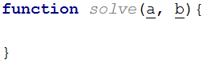
The remaining operations are straightforward arithmetic and finally printing the two results (area and perimeter) to the console.
- Distance over Time
Two objects start from point A and travel in the same direction at constant speeds V₁ and V₂ for a period T. Write a JS function that calculates the distance between the two object at the end of the period.
The input comes as array of numbers. The first two elements are the speeds to the two objects in km/h and the third element is the time in seconds.
The output should be printed to the console. Calculate the distance in meters.
Examples
Input | Output
[0, 60, 3600] | 60000
[11, 10, 120] | 33.33333333333337
[5, -5, 40] | 111.11111111111111
Hints
Speed, time and distance are related to each other with the following formula:
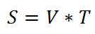
However, the incoming units need to be equalized first and after the calculation, a final conversion needs to be done to match the required output units. There are 3600 seconds in an hour and 1000 meters in a kilometer. We don’t know which object covered a greater distance, so simply subtracting them from one another may result in a negative number. Distance however is absolute (always positive), so we need to get the absolute value of the operation, using the built-in Math.abs(number) functions:
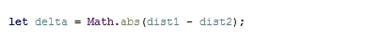
- Distance in 3D
Write a JS function that calculates the distance between the two points in 3D by given coordinates.
The input comes as an array of numbers. The first three elements are the x, y and z coordinates for the first point and the second set of arguments are the coordinates of the other point.
The output should be printed to the console.
Examples
Input | Output
[1, 1, 0, 5, 4, 0] | 5
[3.5, 0, 1, 0, 2, -1] | 4.5
Hints
You can find the horizontal and vertical offset between two points by calculating the difference between their respective coordinates. Use Pythagoras’ theorem to find the distance.
- Grads to Degrees
Land surveyors use grads (also known as gon, 400 grads in a full turn) in their documents. Grads are rather unwieldy though, so you need to write a JS function that converts from grads to degrees. In addition, your program needs to constrain the results within the range , so if you arrive at a value like -15°, it needs to be converted to 345° and 420° becomes 60°.
The input comes as single number.
The output should be printed to the console.
Examples
Input | Output |  | Input | Output |  | Input | Output |  | Input | Output
100 | 90 |  | 400 | 0 |  | 850 | 45 |  | -50 | 315
Hints
You can use the remainder (modulo) operator to get a value that is cyclic – it returns the same result for all input values with offset equal to the second parameter. For instance, n % 10 will return 3 with values for n 3, 13, 23, 243, 1003 and so on.
- Compound Interest
Write a JS function that calculates the total accumulated value for a monetary deposit by given principal sum, interest rate, compounding frequency and overall length.
The input comes as an array of numbers. The first value is the principal sum, the second is the interest rate in percent, the third is the compounding period in months and the final value is the total timespan, given in years.
The output should be printed to the console, with two decimal places.
Examples
Input | Output |  | Input | Output
[1500, 4.3, 3, 6] | 1938.84 |  | [100000, 5, 12, 25] | 338635.49
Hints
The formula for calculating compound interest is as follows:
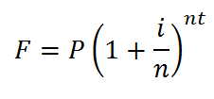
where:
- P is the principal sum
- i is the nominal interest rate
- n is the compounding frequency
- t is the overall length of time the interest is applied
Note that at the beginning of the task you are given the compounding period, which is inversely related to the frequency. You need to express the frequency as how many times in a year the interest is compounded. For instance, a 3-month period means the interest will be updated 4 times in a year. Any percentages need to be expressed as a fraction.
- *Rounding
Write a JS function that rounds numbers to specific precision.
The input comes as an array of two numbers. The first value is the number to be rounded and the second is the precision (significant decimal places). If a precision is passed, that is more than 15 it should automatically be reduced to 15.
The output should be printed to the console. Do not print insignificant decimals.
Examples
Input | Output |  | Input | Output
[3.1415926535897932384626433832795, 2] | 3.14 |  | [10.5, 3] | 10.5
- Imperial Units
Imperial units are confusing, but still in use in some backwards countries (Myanmar, Liberia and the United States are the only countries still using them). They are so confusing in fact, that native users struggle to convert between them. Write a JS function that converts from inches to feet and inches. There are 12 inches in a foot. See the example for formatting details.
The input comes as a single number.
The output should be printed to the console.
Examples
Input | Output |  | Input | Output |  | Input | Output
36 | 3'-0" |  | 55 | 4'-7" |  | 11 | 0'-11"
- Now Playing
Write a JS function that displays information about the currently playing musical track.
The input comes as an array of string elements. The first element is the name of the track, the second is the name of the artist performing and the third is the duration in minutes and seconds.
The output should be printed to the console in the following format:
Now Playing: {artist name} - {track name} [{duration}]
Examples
Input | Output
['Number One', 'Nelly', '4:09'] | Now Playing: Nelly – Number One [4:09]

- Compose Tag
Write a JS function that composes an HTML image tag.
The input comes as an array of string elements. The first element is the location of the file and the second is the alternate text.
The output should be printed to the console in the following format:
<img src="{file location}" alt="{alternate text}">
Examples
Input | Output
['smiley.gif', 'Smiley Face'] | <img src="smiley.gif" alt="Smiley Face">
- Binary to Decimal
Write a JS function that reads an 8-bit binary number and converts it to a decimal.
The input comes as one string element, representing a binary number.
The output should be printed to the console.
Examples
Input | Output |  | Input | Output
00001001 | 9 |  | 11110000 | 240
- Assign Properties
Write a JS function that composes an object by given properties. There will be 3 sets of property-value pairs (a total of 6 elements). Assign each value to its respective property of an object and return the object as a result of the function.
The input comes as an array of string elements.
The output should be returned as a value.
Examples
Input
['name', 'Pesho', 'age', '23', 'gender', 'male']
Output
{
name: 'Pesho',
age: '23',
gender: 'male'
}

Input
['ssid', '90127461', 'status', 'admin', 'expires', '600']
Output
{
ssid: '90127461',
status: 'admin',
expires: '600'
}
- *Last Month
Write a JS function that receives a date as array of strings containing day, month and year in that order. Your task is to print the last day of previous month (the month BEFORE the given date). Check the examples to better understand the problem.
The input comes as an array of numbers.
The output should be a single number representing the last day of the previous month.
Examples
Input | Output |  | Input | Output
[17, 3, 2002] | 28 |  | [13, 12, 2004] | 30
Conditional Statements and Loops
In this homework, you are supposed to write program logic using expressions, conditions and loops in JavaScript. You will practice working with arithmetic operators, expressions and calculations, using conditional statements (if, if-else, multiple if-else-if-else-… and switch-case) and working with loop statements (like for, while, do-while and for-of) and nested loops, combined with conditional statements and calculations.
- Biggest of 3 Numbers
Write a JS function that finds the biggest of 3 numbers.
The input comes as array of 3 numbers.
The output is the biggest from the input numbers.
Examples
Input | Output |  | Input | Output |  | Input | Output |  | Input | Output |  | Input | Output
5  -2  7 | 7 |  | 130  5  99 | 130 |  | 43  43.2  43.1 | 43.2 |  | 5  5  5 | 5 |  | -10  -20  -30 | -10
Hints
Read the input and assign each number to a variable:
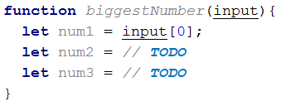
You may use Math.max(num1, num2, num3) to find the biggest number. It will automatically convert strings to numbers, so parsing the input elements to number might not be obligatory. Your code might look like this:
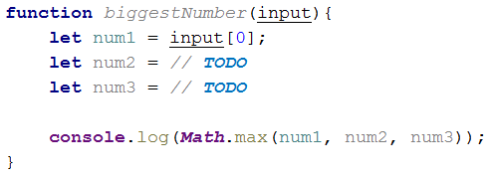
Test the above code locally by invoking the biggestNumber() function like this:
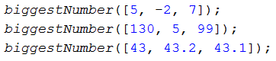
Test the above code locally in your Web browser:
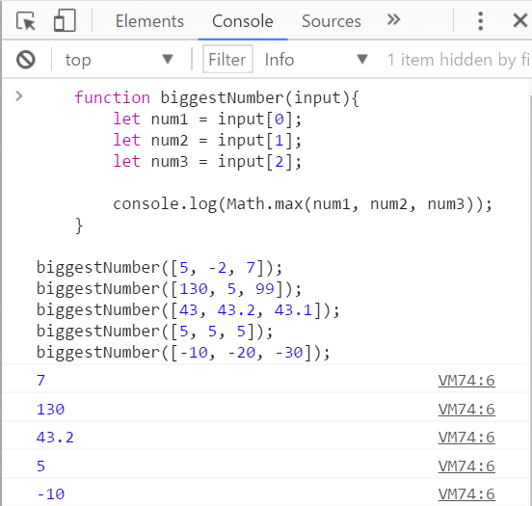
Finally, submit your code in the judge system: https://judge.softuni.bg/Contests/Practice/Index/300.
Note: the above code might be shortened like this:
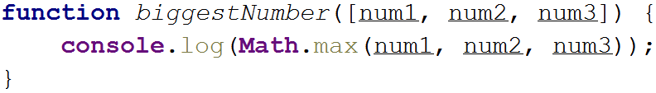
The above code takes the input as array of 3 string variables num1, num2 and num3. Then the function Math.max(…) converts its string arguments to numbers and returns the biggest of them.
You may shorten further your solution by making it an arrow function like the shown below:
The judge system will accept the above solution as correct.
In the judge you can also return the expected result instead of printing it at the console, so the following solution will also be accepted by the judge, as well:
The above code could be even further shortened like this:
The judge system will accept the above arrow function as correct solution, passing all the tests.
Enjoy!
- Point in Rectangle
Write a JS function that takes as input 6 numbers x, y, xMin, xMax, yMin, yMax and prints whether the point {x, y} is inside the rectangle or outside of it. If the point is at the rectangle border, it is considered inside.
The input comes as array of numbers. Its holds the representations of x, y, xMin, xMax, yMin, yMax. All numbers will in the range [-1 000 000 … 1 000 000]. It is guaranteed that xMin < xMax and yMin < yMax.
The output is a single line holding “inside” or “outside”.
Examples
Input | Output | Figure |  | Input | Output | Figure
8  -1  2  12  -3  3 | inside | 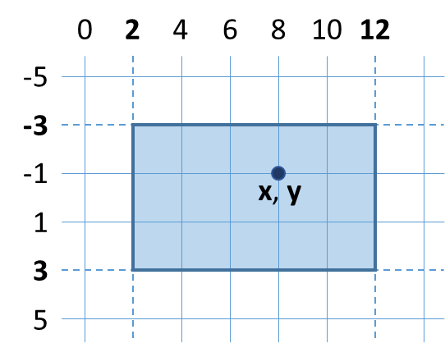 |  | 12.5  -1  2  12  -3  3 | outside | 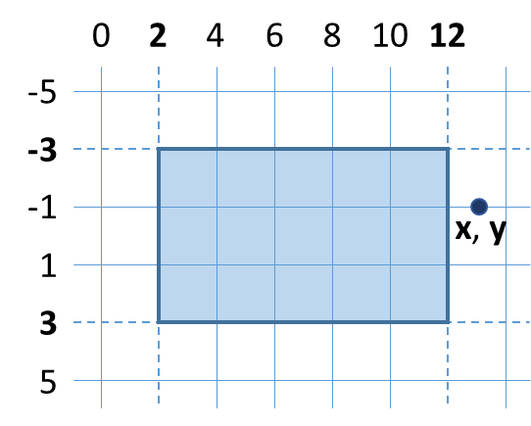
Hints
First write a JS function to read the input numbers x, y, xMin, xMax, yMin and yMax from the array of 6 numbers, passed as input parameter input. The numbers should be taken from the array elements input[0], input[1], … as follows:
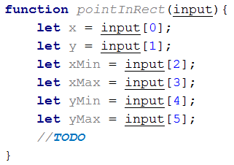
The above code could be significantly shortened by using a JS language feature called “destructuring assignment” like this:
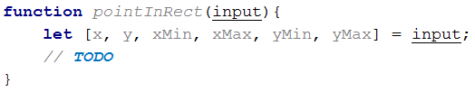
Next, write if-else statement to check whether the point {x, y} is inside the rectangle. A point is inside a rectangle if and only if both of the following conditions are fulfilled:
- its x coordinate is between xMin and xMax
- its y coordinate is between yMin and yMax
The code may look like this:
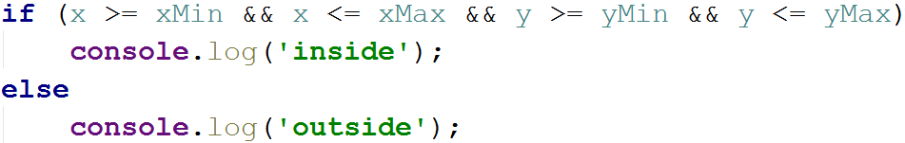
Now test the function locally on your computer. Invoke the above function like this:
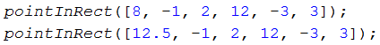
Note that the function takes its input as 6 numbers. You may test your code in your IDE, in the console (with Node.js) or in your Web browser’s JS console.
The screenshot below shows the above function, invoked in Chrome JavaScript Console:
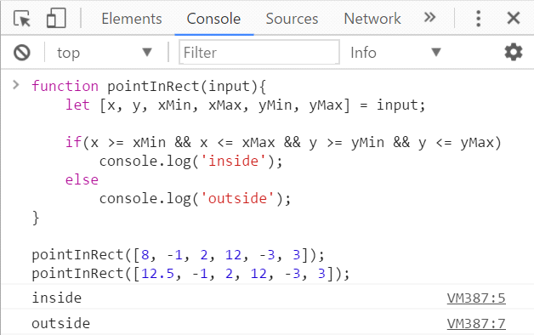
The screenshot below shows the above code in the Node.js REPL console:
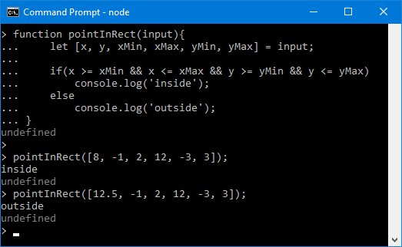
Now you are ready to submit your solution in the judge system. Open the judge contest for this homework and submit your code: https://judge.softuni.bg/Contests/Practice/Index/300. It should look like this:
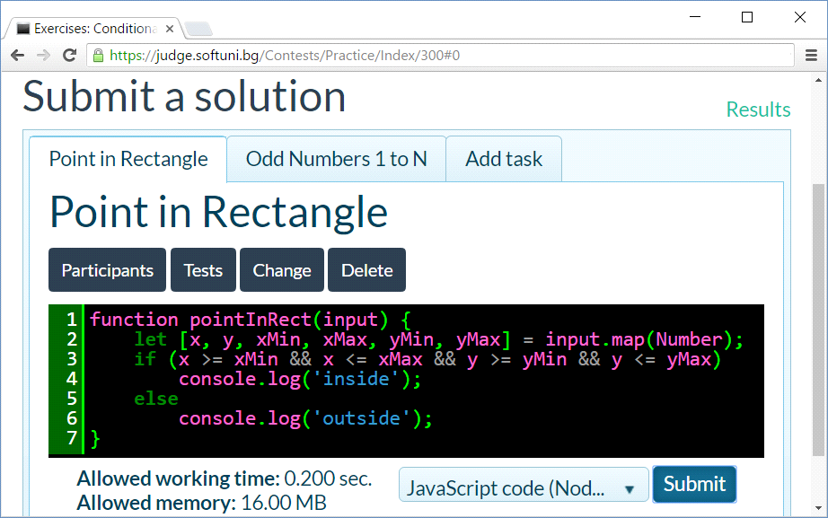
The judge system should accept your solution as correct:
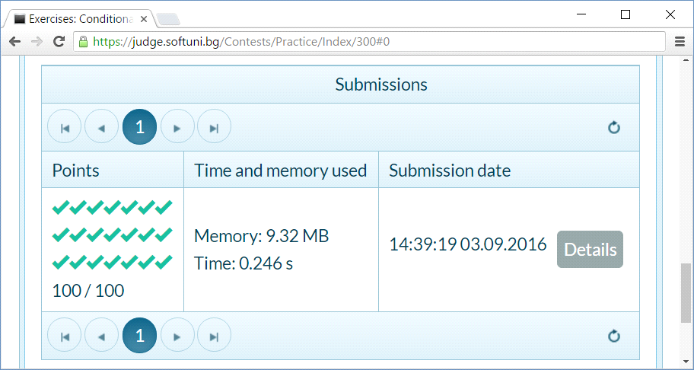
- Odd Numbers 1 to N
Write a JS function that reads an integer n and prints all odd numbers from 1 to n.
The input comes as a single number n. The number n will be an integer in the range [1 … 100 000].
The output should hold the expected odd numbers, each at a separate line.
Examples
Input | Output |  | Input | Output |  | Input | Output
5 | 1  3  5 |  | 4 | 1  3 |  | 7 | 1  3  5  7
Hints
First write a JS function to read the input number n.
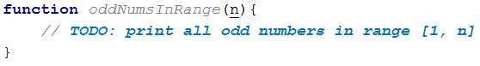
Next, write a for-loop from 1 to n with step 2:
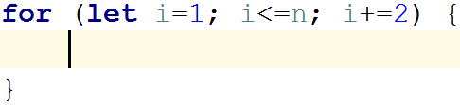
Finally, print the number i at each iteration of the for-loop. The entire function should look like this:
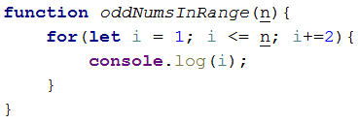
Now test the function locally on your computer. Invoke the above function like this:
You may test your code in the console (with Node.js) or in your Web browser’s JS console.
The screenshot below shows the above function, invoked in Chrome JavaScript Console:
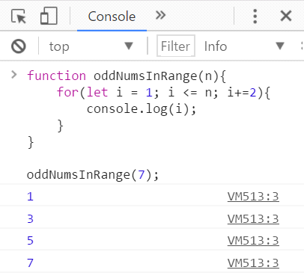
The screenshot below shows the above code in the Node.js REPL console:
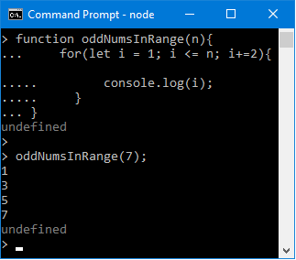
Now you are ready to submit the problem in the judge system. Open the judge contest for this homework and submit your code: https://judge.softuni.bg/Contests/Practice/Index/300. It should look like this:
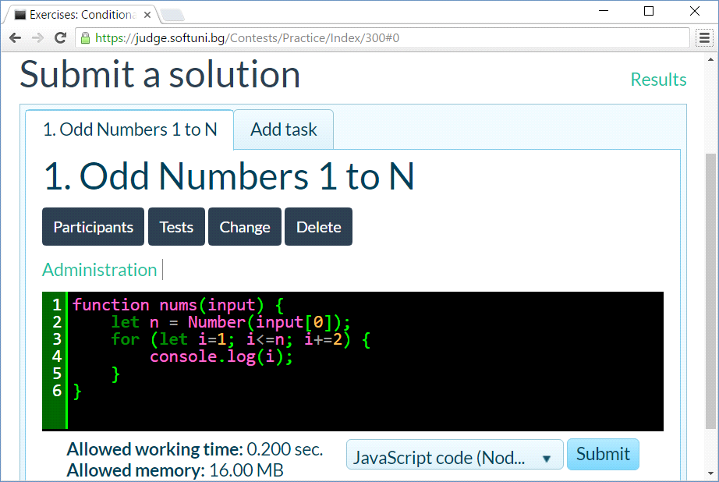
The judge system should accept your solution as correct:
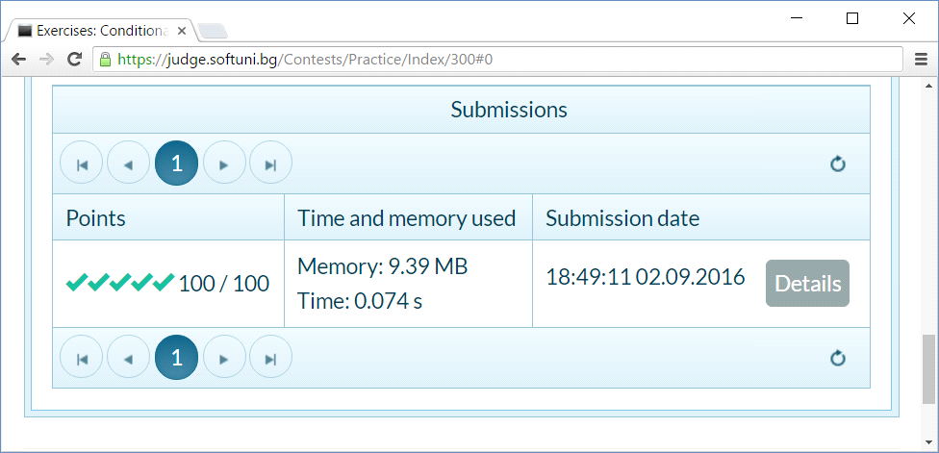
- Triangle of Dollars
Write a JS function that prints a triangle of n lines of “$” characters like shown in the examples.
The input comes as a single number n (0 < n < 100).
The output consists of n text lines like shown below.
Examples
Input | Output |  | Input | Output |  | Input | Output
3 | $  $$  $$$ |  | 2 | $  $$ |  | 4 | $  $$  $$$  $$$$
Hints
Variant 1: use nested loops and for each row collect the ‘$’ characters in a string and then print it:
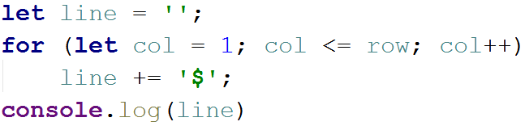
Variant 2: use a simple loop row = 1 … n and print row dollars this way:
Variant 3: you can print row dollars by repeating the '$' string row times:
- Movie Prices
Movie ticket prices in a big retro-cinema depend on the movie title and on the day of week as shown below:
Movie Title | Monday | Tuesday | Wednesday | Thursday | Friday | Saturday | Sunday
The Godfather | 12 | 10 | 15 | 12.50 | 15 | 25 | 30
Schindler's List | 8.50 | 8.50 | 8.50 | 8.50 | 8.50 | 15 | 15
Casablanca | 8 | 8 | 8 | 8 | 8 | 10 | 10
The Wizard of Oz | 10 | 10 | 10 | 10 | 10 | 15 | 15
Write a JS function that calculate the ticket price by movie title and day of week.
The input comes as array of 2 strings. The first string holds the movie title. The second string holds the day of week.
The output should hold the ticket price or “error” if the title or day of week is invalid.
Examples
Input | Output |  | Input | Output |  | Input | Output |  | Input | Output
The Godfather  Friday | 15 |  | casablanca  sunday | 10 |  | Schindler's LIST  monday | 8.50 |  | SoftUni  Nineday | error
Hints
- Turn all input values to lowercase to avoid character casing mistakes.
- Check the movie title in if-else-if statement.
- For each movie title check the price in a switch-case.
- Beware of invalid movie titles and invalid days of week. Show “error” in such cases.
You may follow the code example below:
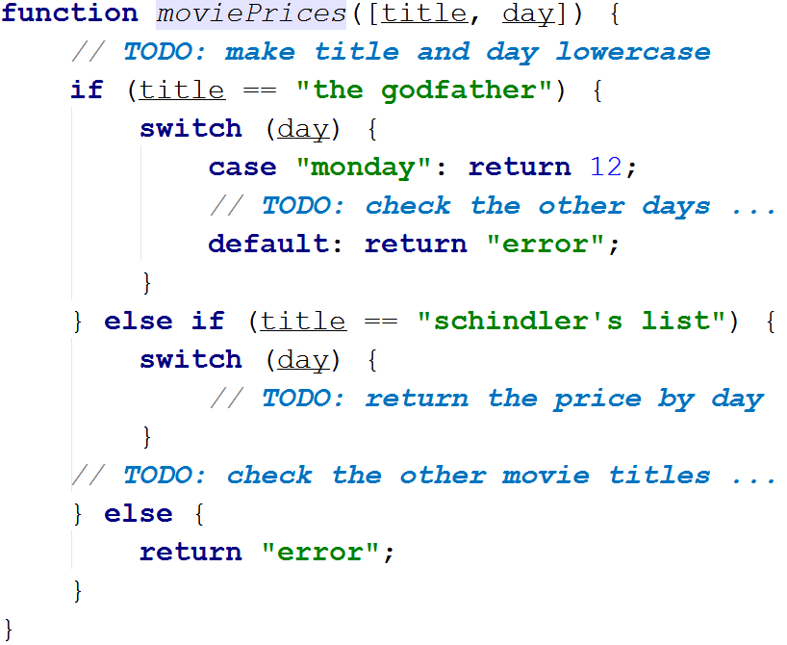
You may test your code locally like this:
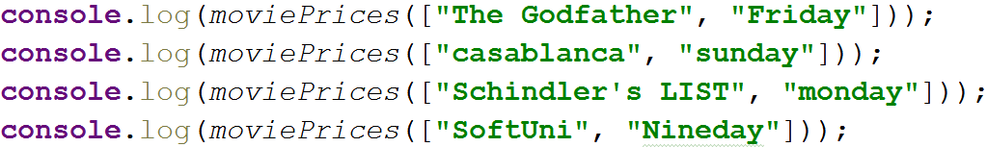
- Quadratic Equation
Write a JS function to solve a quadratic equation by given in standard form as its coefficients: a, b, c. You may learn more about quadratic equations here: https://www.mathsisfun.com/algebra/quadratic-equation.html.
The input comes as 3 numbers a, b and c. The value of a will be non-zero.
The output depends on the equation:
- It holds two numbers x₁ and x₂ if the equation has two different solutions (roots): x₁ and x₂.
- First print the smaller root, then the greater.
- It holds a single number x if the equation has only one solution (root): x.
- It holds the text “No” if the equation has no solutions (no real roots).
Examples
Input | Output | Comments
6  11  -35 | -3.5  1.66667 | The equation is: 6x² + 11x - 35 = 0 a = 6; b = 11; c = -35  The discriminant is: d = b² - 4*a*c = 11*11 - 4*6*(-35) = 121 + 840 = 961  We have positive discriminant (d > 0), so the equation has two real roots:  - x₁ = (-b + √d) / (2*a) = (-11 + 31) / 12 = 20/12 = 5/3 ≈ 1.66667  - x₂ = (-b - √d) / (2*a) = (-11 - 31) / 12 = -42/12 = -7/2 = -3.5  The output consists of two lines:  - -3.5 (the smaller root at the first line)  - 1.66667 (the bigger root at the second line)
1  -12  36 | 6 | The equation is: x² - 12x + 36 = 0 a = 1; b = -12; c = 36  The discriminant is: d = b² - 4*a*c = -12*-12 - 4*1*36 = 144 - 144 = 0  We have zero discriminant (d = 0), so the equation has only one real root:  - x = -b / (2*a) = 12 / 2 = 6  The output is only one line, holding the number 6.
5  2  1 | No | The equation is: 5x² - 2x + 1 = 0 a = 5; b = -2; c = 1  The discriminant is: d = b² - 4*a*c = -2*-2 - 4*5*1 = 4 - 20 = -16  We have negative discriminant (d < 0), so the equation has no real roots.  The output is only one line, holding the text “No”.
Hints
- Search for “solving quadratic equation” in Internet.
- Use if-conditions and expressions to calculate the discriminant and the equation roots (if any).
- Multiplication Table
Write a JS function to print a math multiplication table of size n, formatted as HTML table.
The input comes as a single number n (0 < n < 100).
The output consists of n+3 text lines like shown below.
Examples
Input | 5
Output | <table border="1">  <tr><th>x</th><th>1</th><th>2</th><th>3</th><th>4</th><th>5</th></tr>  <tr><th>1</th><td>1</td><td>2</td><td>3</td><td>4</td><td>5</td></tr>  <tr><th>2</th><td>2</td><td>4</td><td>6</td><td>8</td><td>10</td></tr>  <tr><th>3</th><td>3</td><td>6</td><td>9</td><td>12</td><td>15</td></tr>  <tr><th>4</th><td>4</td><td>8</td><td>12</td><td>16</td><td>20</td></tr>  <tr><th>5</th><td>5</td><td>10</td><td>15</td><td>20</td><td>25</td></tr>  </table>
Preview | 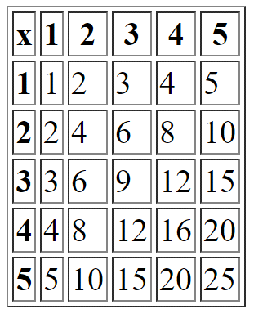
Hints
- Create a function multiplicationTable(n) { … }. It will return a table of size n.
- First, print the “<table border='1'>” opening tag.
- Using a simple loop, print the heading row.
- It should hold <tr> + “x” + the numbers 1…n (all surrounded in <td></td>) + </tr>.
- Print the next n lines using nested loops.
- For each line start with <tr>, then append its elements in a loop (all surrounded in <td></td>) and finally append </tr>.
- After the loops, at the end, print the “</table>” closing tag.
- You may visualize your code’s output in the browser like this:
- Figure of 4 Squares
Write a JS function to print a figure of 4 squares of size n like shown in the examples below.
The input is an integer number n in the range [2 … 200].
The output consists of n lines for odd n and n-1 lines for even n. Each line holds 2*n-1 characters (+ or | or space) as shown in the examples. The figure is fully symmetric (horizontally and vertically).
Examples
Input | Output |  | Input | Output |  | Input | Output |  | Input | Output
4 | +--+--+  +--+--+  +--+--+ |  | 5 | +---+---+  | | |  +---+---+  | | |  +---+---+ |  | 6 | +----+----+  | | |  +----+----+  | | |  +----+----+ |  | 7 | +-----+-----+  | | |  | | |  +-----+-----+  | | |  | | |  +-----+-----+
Hints
- Use nested loops and if-statements. Try to figure out the logic of construction of the above figures.
- ** Monthly Calendar
Note: this problem is for champions only!
Write a JS function calendar([day, month, year]) that returns a monthly calendar as HTML table (like in the examples below) by given day, month and year. Weeks start by “Sun” (Sunday) and end by “Sat” (Saturday).
The input comes as array of 3 numbers:
- day (1 ≤ day ≤ 31)
- month (1 ≤ month ≤ 12)
- year (1900 ≤ year ≤ 2100)
The output should be an HTML table, holding the calendar rows and columns, like in the examples below. Display the weeks as table rows: <tr>…</tr>. Display the days as table cells: <td>…</td>. Display the days of the previous month with CSS class “prev-month”, the days of the next month with CSS class “next-month” and the current day with CSS class “today”. See the examples below.
Examples
Input | 24  12  2012
Output | <table>  <tr><th>Sun</th><th>Mon</th><th>Tue</th><th>Wed</th><th>Thu</th><th>Fri</th><th>Sat</th></tr>  <tr><td class="prev-month">25</td><td class="prev-month">26</td><td class="prev-month">27</td><td class="prev-month">28</td><td class="prev-month">29</td><td class="prev-month">30</td><td>1</td></tr>  <tr><td>2</td><td>3</td><td>4</td><td>5</td><td>6</td><td>7</td><td>8</td></tr>  <tr><td>9</td><td>10</td><td>11</td><td>12</td><td>13</td><td>14</td><td>15</td></tr>  <tr><td>16</td><td>17</td><td>18</td><td>19</td><td>20</td><td>21</td><td>22</td></tr>  <tr><td>23</td><td class="today">24</td><td>25</td><td>26</td><td>27</td><td>28</td><td>29</td></tr>  <tr><td>30</td><td>31</td><td class="next-month">1</td><td class="next-month">2</td><td class="next-month">3</td><td class="next-month">4</td><td class="next-month">5</td></tr>  </table>
Preview | 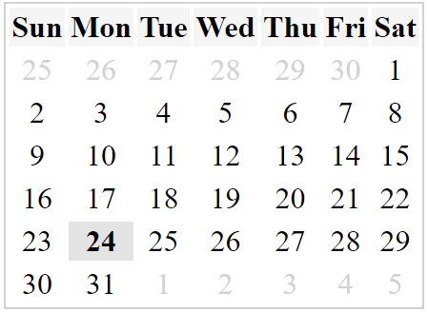

Input | 4  9  2016
Output | <table>  <tr><th>Sun</th><th>Mon</th><th>Tue</th><th>Wed</th><th>Thu</th><th>Fri</th><th>Sat</th></tr>  <tr><td class="prev-month">28</td><td class="prev-month">29</td><td class="prev-month">30</td><td class="prev-month">31</td><td>1</td><td>2</td><td>3</td></tr>  <tr><td class="today">4</td><td>5</td><td>6</td><td>7</td><td>8</td><td>9</td><td>10</td></tr>  <tr><td>11</td><td>12</td><td>13</td><td>14</td><td>15</td><td>16</td><td>17</td></tr>  <tr><td>18</td><td>19</td><td>20</td><td>21</td><td>22</td><td>23</td><td>24</td></tr>  <tr><td>25</td><td>26</td><td>27</td><td>28</td><td>29</td><td>30</td><td class="next-month">1</td></tr>  </table>
Preview | 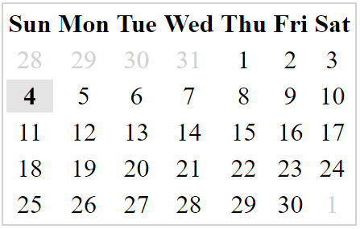
HTML Skeleton
To simplify your work, use the below HTML code and write the missing code in the calendar() function:
calendar.html
<!DOCTYPE html>
<html>
<head>
<title>Monthly Calendar</title>
<style>
.prev-month, .next-month { color: #CCC }
.today { font-weight: bold; background: #DDD; }
.title { background: #AAAAFF; margin: 10px 0; padding:5px }
table { border: 1px solid #CCC;}
td { text-align: center; }
#calendarCode { width: 100%; }
</style>
<script>
function calendar([day, month, year])
{
// TODO: return the HTML text holding the calendar table
}
</script>
</head>
<body>
Day: <input id="day" type="number" value="4" />
Month: <input id="month" type="number" value="9" />
Year: <input id="year" type="number" value="2016" />
<input type="button" value="Show"
onclick="let calendarHTML =
calendar([document.getElementById('day').value,
document.getElementById('month').value,
document.getElementById('year').value]);
document.getElementById('calendar').innerHTML = calendarHTML;
document.getElementById('calendarCode').innerText = calendarHTML" />
<div class="title">Calendar:</div>
<div id="calendar">Calendar will be shown here</div>
<div class="title">HTML:</div>
<textarea rows="12" id="calendarCode"></textarea>
</body>
</html>
Submit in the judge system the JS code of your calendar() function only, without the above HTML code that visualizes the calendar in the Web browser.
Screenshot
This is how your calendar should look in Web browser, when the calendar() function is implemented correctly:
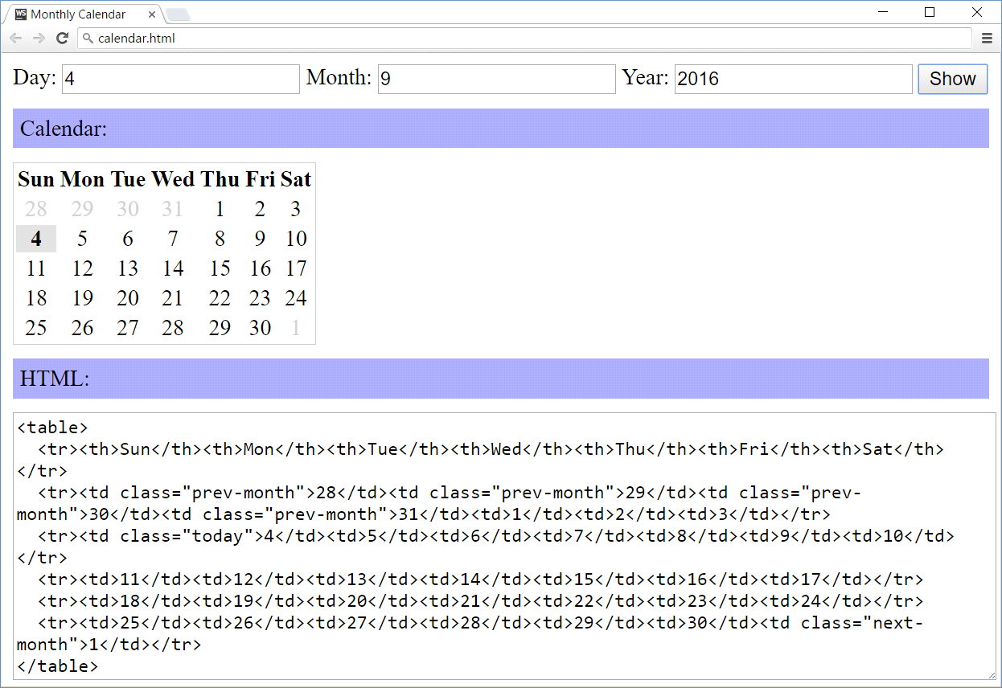
Hints
- Printing a calendar in JS without using an external library is not as simple as the previous problems in this exercise! It may take a few hours or even more to implement it correctly.
- Play with the class Date in JavaScript and make some calculations.
- You may also search in Google, e.g. try “JavaScript calendar code example”.
- Print the calendar table headings + days.
- Print the days from the previous month (if any).
- Find the day of week for the first day of the input date.
- If it is not Sunday, days from the previous month exist.
- Go back a few days in the previous month to find the closest Sunday (first week day).
- Start from it and print the days until the end of the previous month.
- Print the days from the current month.
- Print the days, one after another.
- Create a new table row after the last week day (Saturday).
- Print the days from the next month (if any).
- Stop when you reach Saturday (the last week day).
- You may start from this code template:
